**Working with decimals (Addition, subtraction, multiplication, and division)**

Decimals are used in everyday life for money, measurements, and more. Therefore, it's essential to know how to add, subtract, multiply, and divide decimals. This article will guide you through these operations with worked examples.

**Adding and subtracting Decimals**

To add or subtract decimals, align the decimal points using the column method, just like with whole numbers. Placeholders (zeroes) may be needed to ensure each column is filled. For example, when subtracting 21.56 from 33.7, add a zero to 33.7 to make it 33.70. This helps when you have to borrow from a place as illustrated in the diagram below.

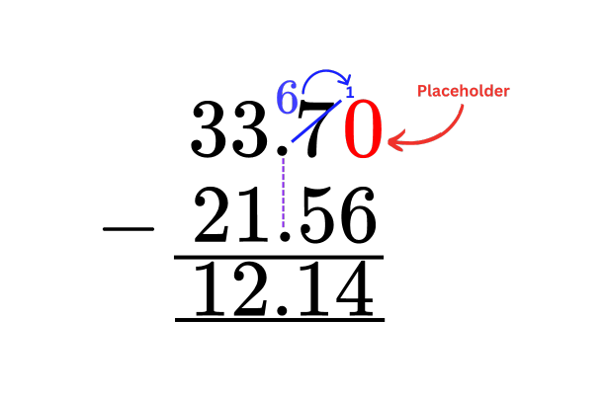

**Multiplication and division of decimals by 10, 100, and 1000**

* Multiplication

To multiply numbers with decimals by powers of 10, like 10, 100, and 1000 it is convenient to visualize using a place value chart.

Note that each time we multiply by 10, the value of each digit increases thus it shifts one place to the left. The following place value chart illustrates how the digits of 23.56 shift when multiplied by 10.

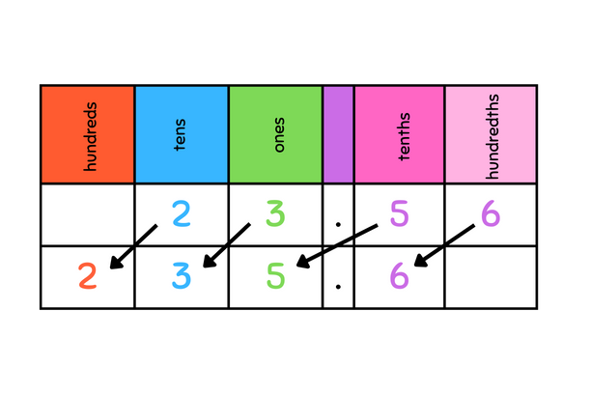

The result is 235.6.

100 is 10 x 10, which is identical to multiplying a number by 10 twice. Hence, to multiply 1.25 by 100 we have to shift each digit two places to the left, to give 125.

You can apply the same approach to multiply any decimal number by any power of 10.

Challenge: Multiply 2.27 by 1000. (Note: Include placeholders for empty places.)

Answer:

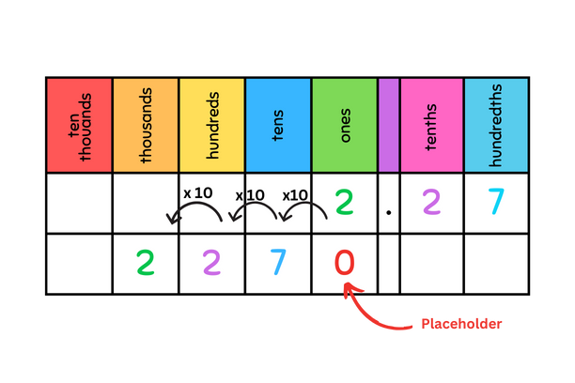

* Division

Division can be thought of as the opposite of multiplication. When we divide a decimal by powers of 10, the value decreases, hence the digits shift to the right. The following diagram illustrates how to divide 105 by 100.

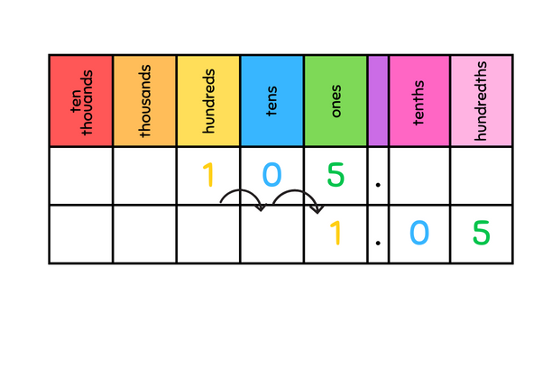

Here the result is 1.05.

**Multiplication of numbers with decimals**

To multiply decimals, convert them into whole numbers by multiplying by powers of 10.

Consider the multiplication of 2.25 by 1.4. 2.25 can be multiplied by 100 to convert it to the whole number 225. While 1.4 can be multiplied by 10 to convert it to 14. **Remember that we will be undoing these changes at the end!**

After converting the decimals to whole numbers, we can multiply them.

We multiplied the multipliers by 100 and 10 for our convenience but this means that we have a result that is larger than the actual result, hence we need to undo the changes. We multiplied the multiplier by 100 and also by 10, so to reverse this we must divide the result by 100 and 10 (or directly divide by 1000).

Using the place value chart method for division we can divide 3150 by 1000 to get 3.15 as shown below.

Thus 2.25 x 1.4 = 3.15

**Division of numbers with decimals**

**Consider the division of 23.85 by 1.8**

* Convert the divisor to a whole number by multiplying both the divisor and the dividend by the same power of 10. Here, multiply by 10:
  + 1.5 becomes 15
  + 23.85 becomes 238.5.
* Perform the long division as you would with whole numbers. Remember to place the decimal point in the quotient in line with that of the dividend.

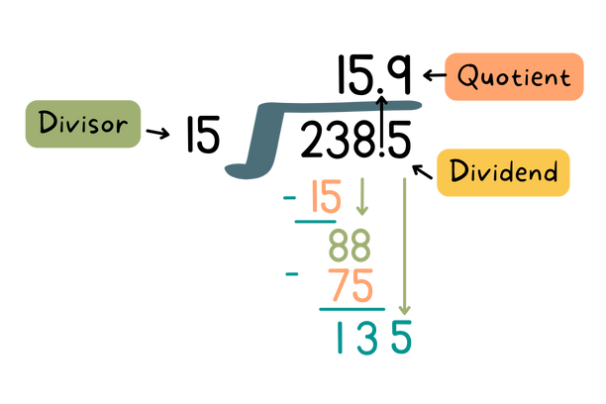

* Final answer: Unlike multiplication, if we make the **same change** to both the divisor and the dividend, the changes balance out, and thus we don’t have to make any further adjustments to the answer.

$23.85 ÷ 1.5 = 15.9$